**P.RAJYALAKSHMI(192011200)USING RAPTOR – SWAP TWO CHARACTERS**

**FLOWCHART**

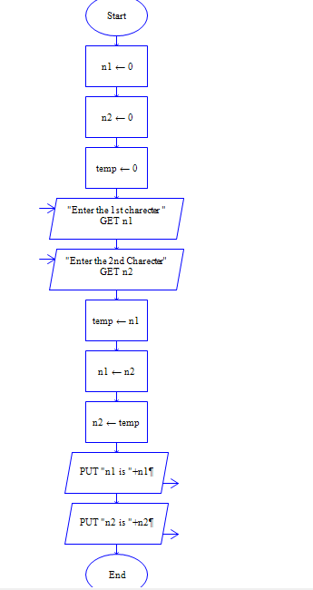

**OUTPUT**

INPUT

N1 =V

N2 = R

